**LITERACY INDIA COMMUNITY COLLEGE**

**Transforming lives.**

**Building resilient community.**

**Programs offered**

* **Robotics/Tinkering**
* **Computer hardware**
* **Mobile Repairing**
* **Cooking/Hospitality**
* **Beauty & wellness**
* **Stitching & cutting**
* **Electrical troubleshooting**
* **Two-wheeler repairing**
* **Mobile journalism**
* **Computer science**
* **Call Centre/ BPO**
* **Logistics**
* **Data digitization**
* **Natural farming Market connect**
* **Banking**

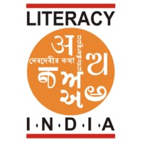

 **hh**

**Limited seats**

**Register now**

[**www.literacyindia.org**](http://www.literacyindia.org)

session start from

Jun 2024

**contact no- 8588853380**